**Fatima Jinnah Women University**

Department of Software Engineering

**LAB 2**

**Name:** Raifa Khalid

**Reg. no:** 2020-BSE-024

**Section:** A

**Semester:** Fourth

**Course:** Data Base (LAB)

TASKS

1. You need to create a database for a public library to store book details. For this, create a blank database and save it.
2. Create a table called “Books” with the following fields.

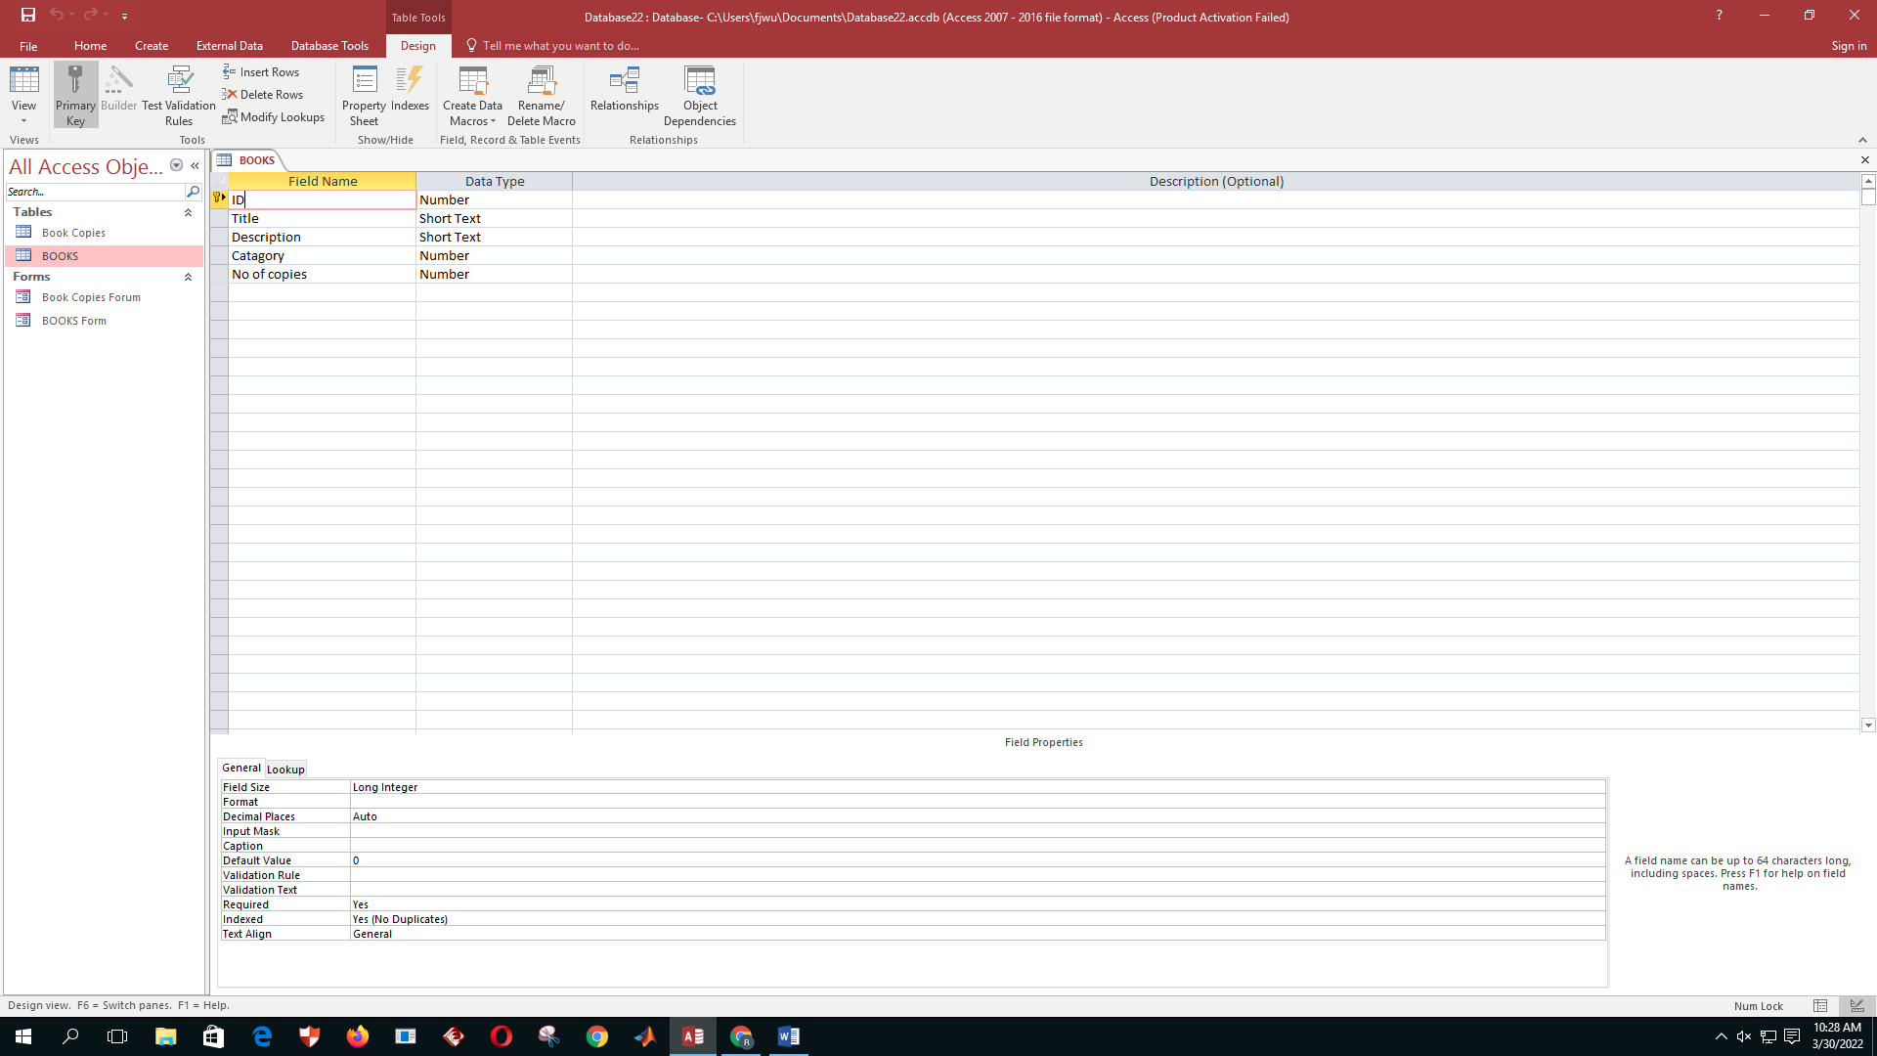

1. Create a form to enter details about books and save it as “Books Form”.
2. Add following records to the “Books” table using the “Books Form”.

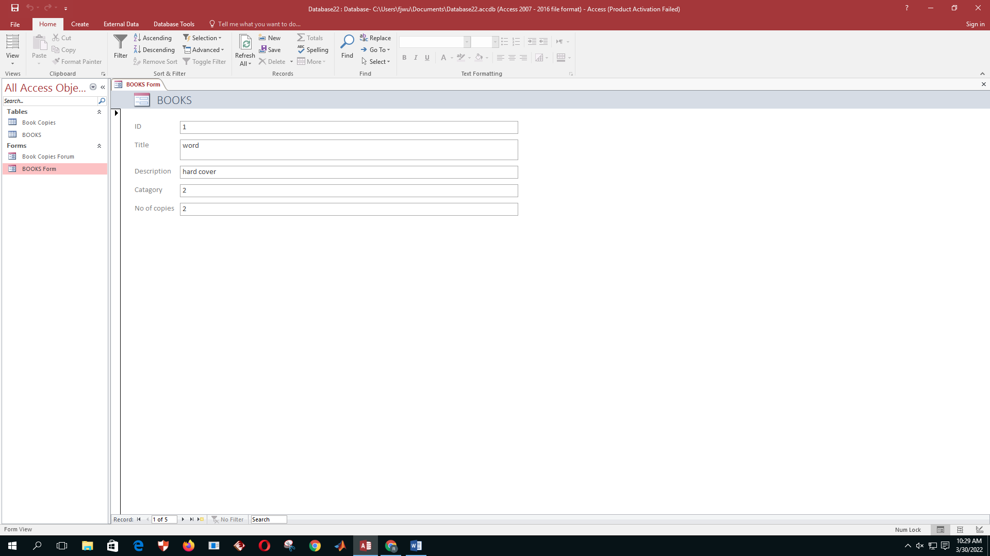

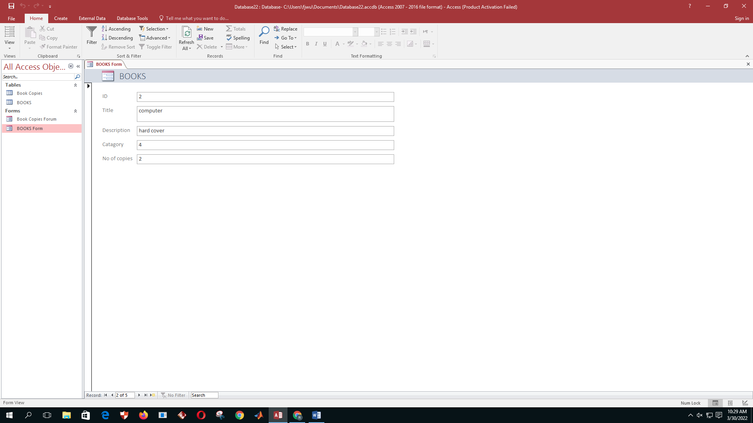

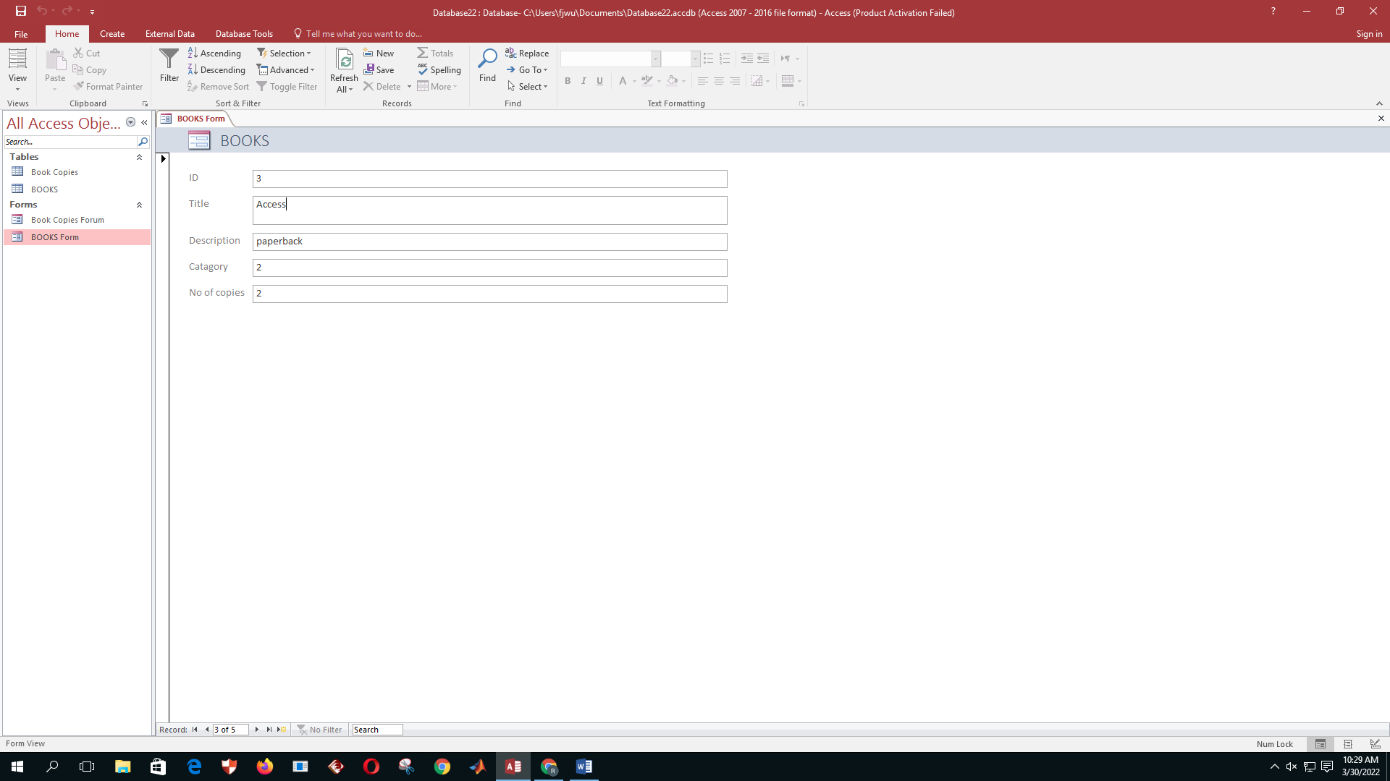

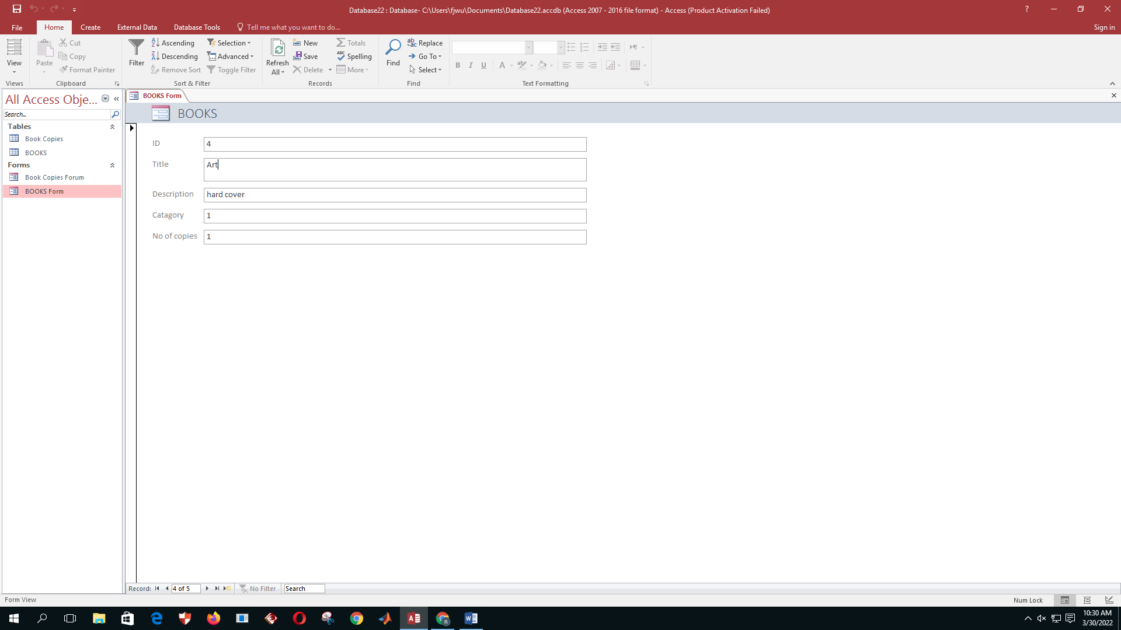

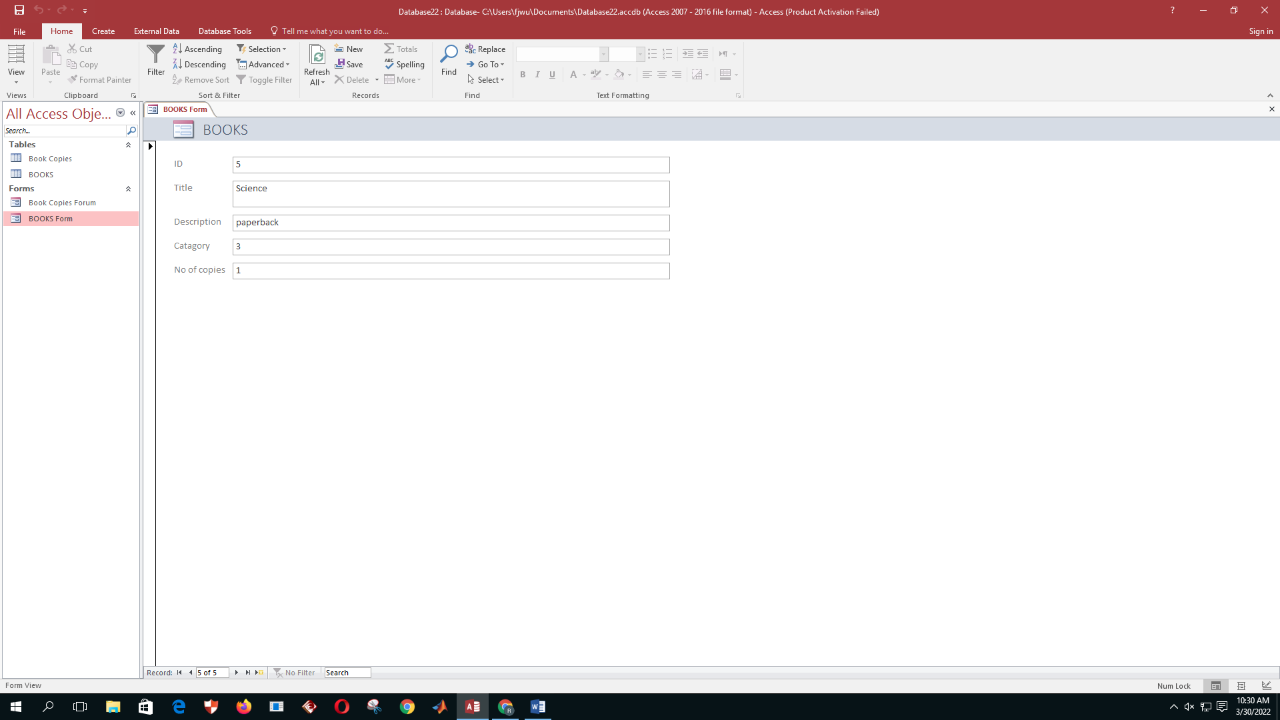

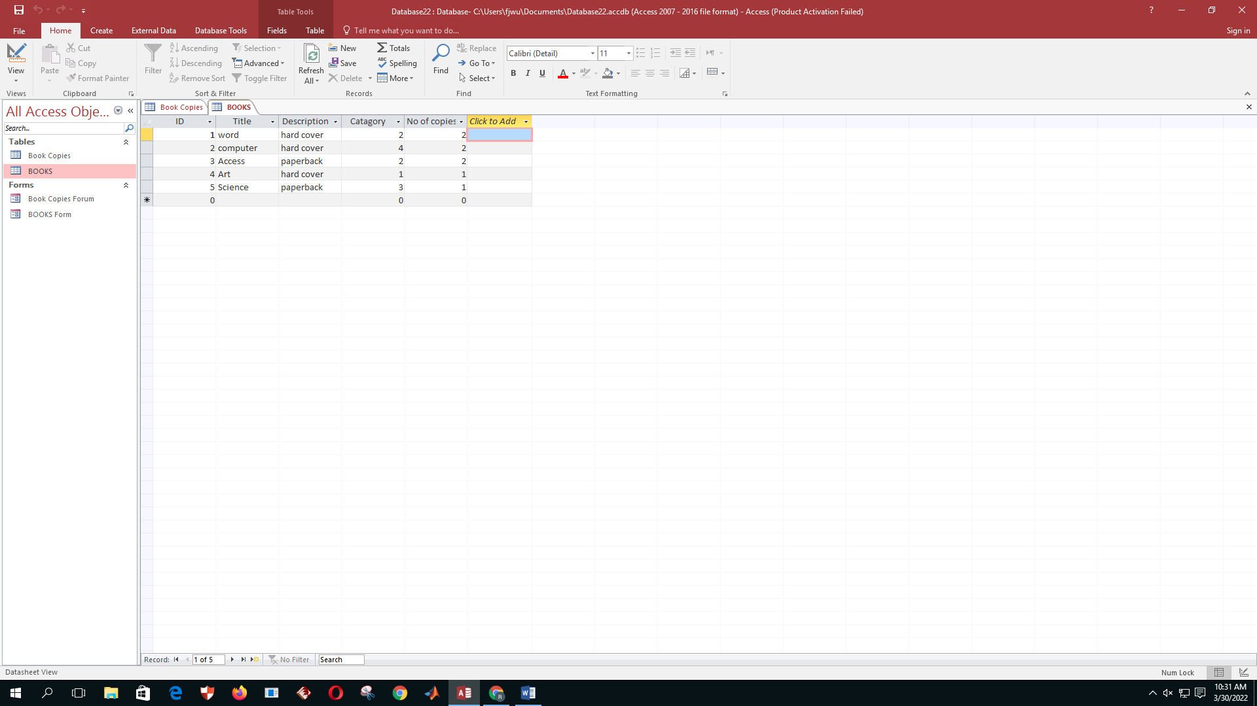

1. Create another table called “Book Copies” with the following fields.

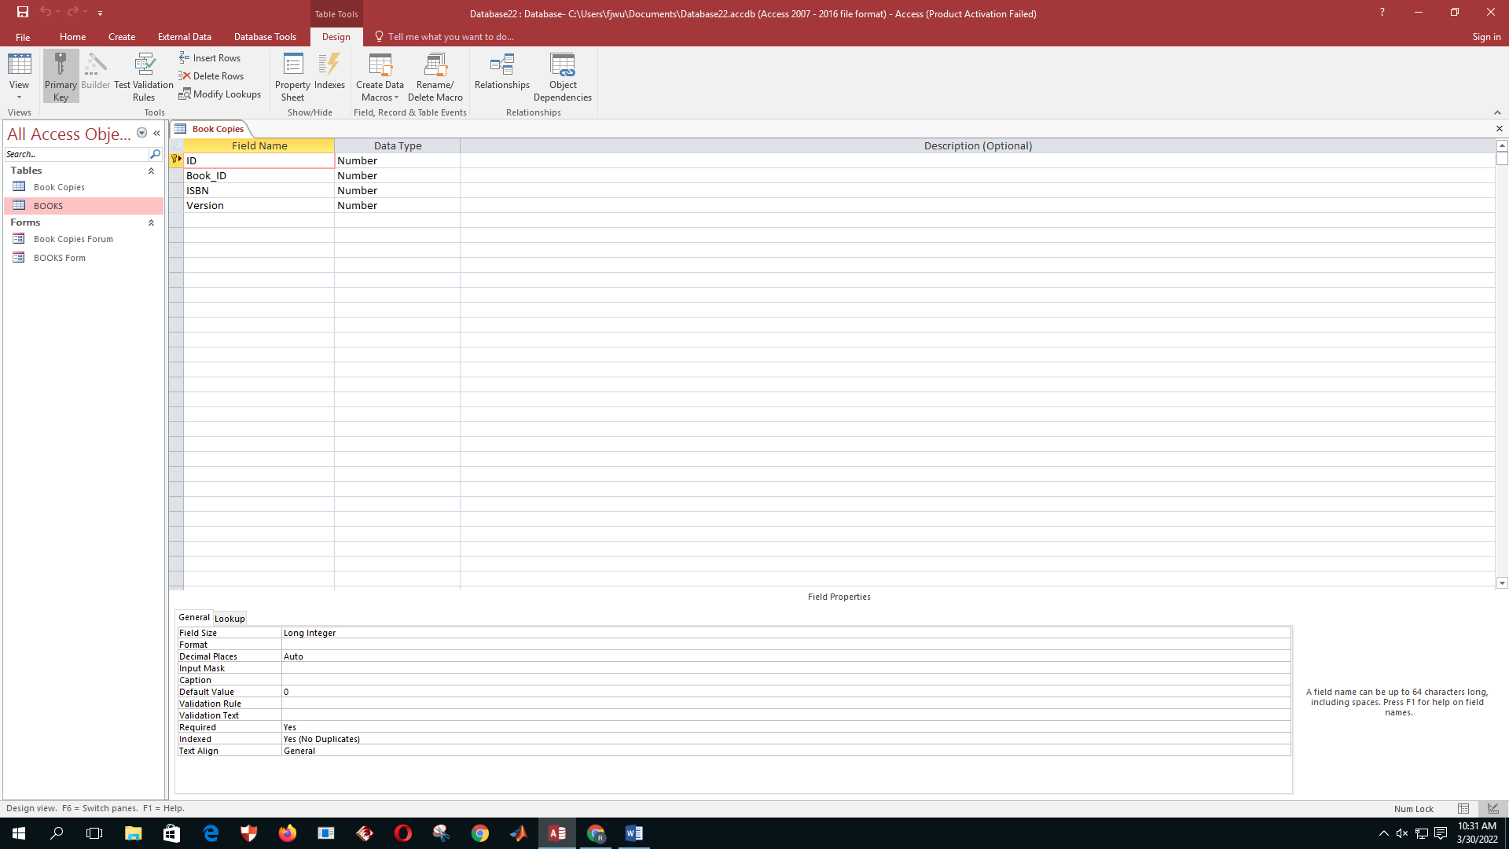

1. Identify the Primary Key(s) of this table (if there is any).
2. Create a form to enter details about books and save it as “Book Copies Form”.
3. Insert following records to the “Book Copies” table using “Book Copies Form”.

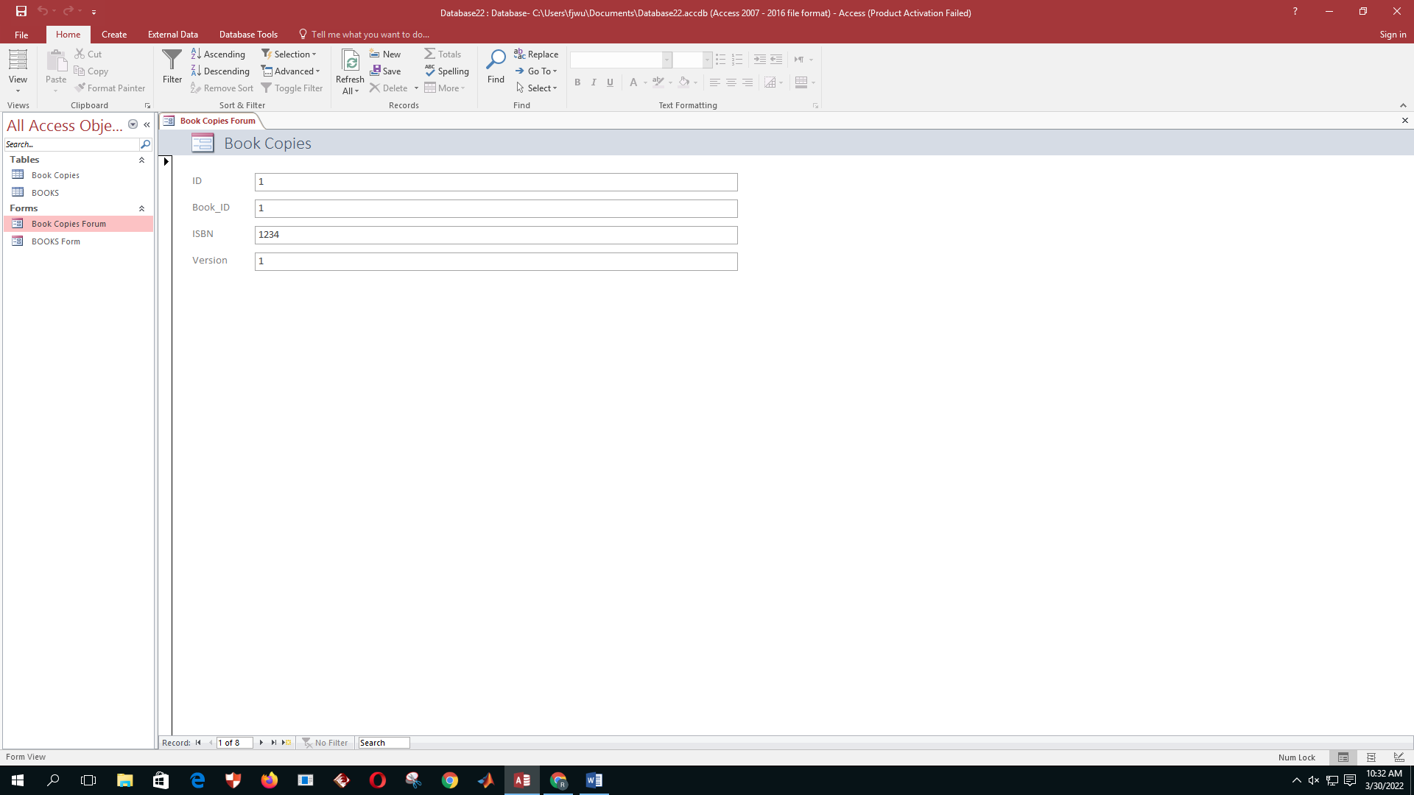

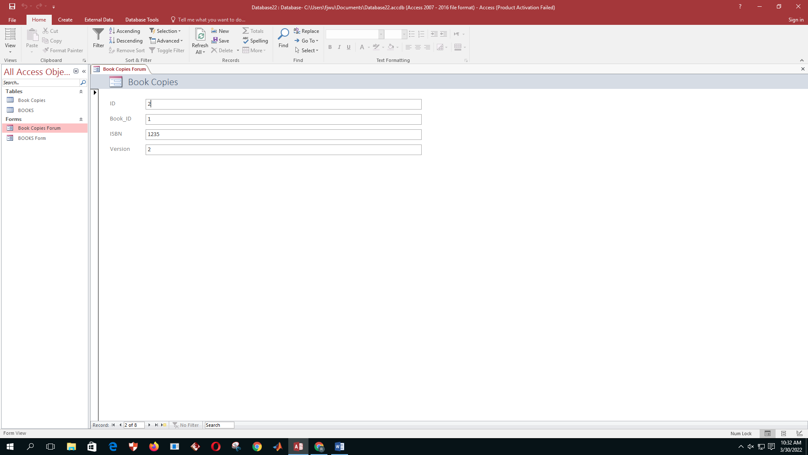

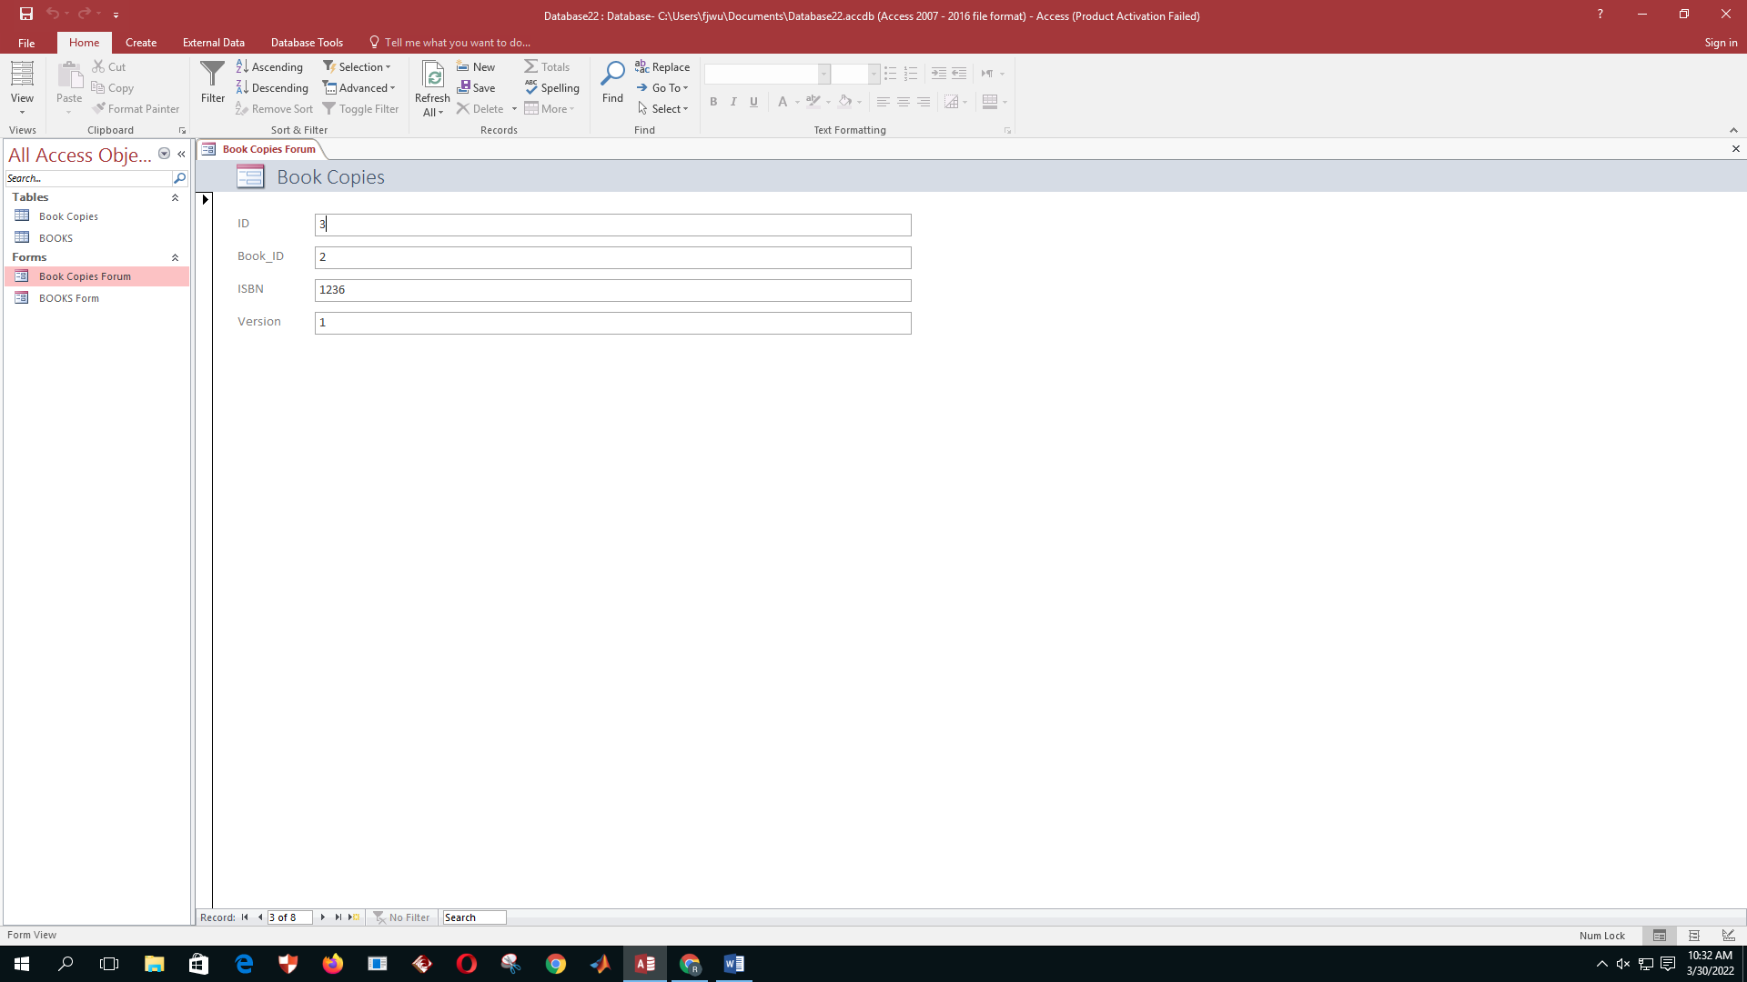

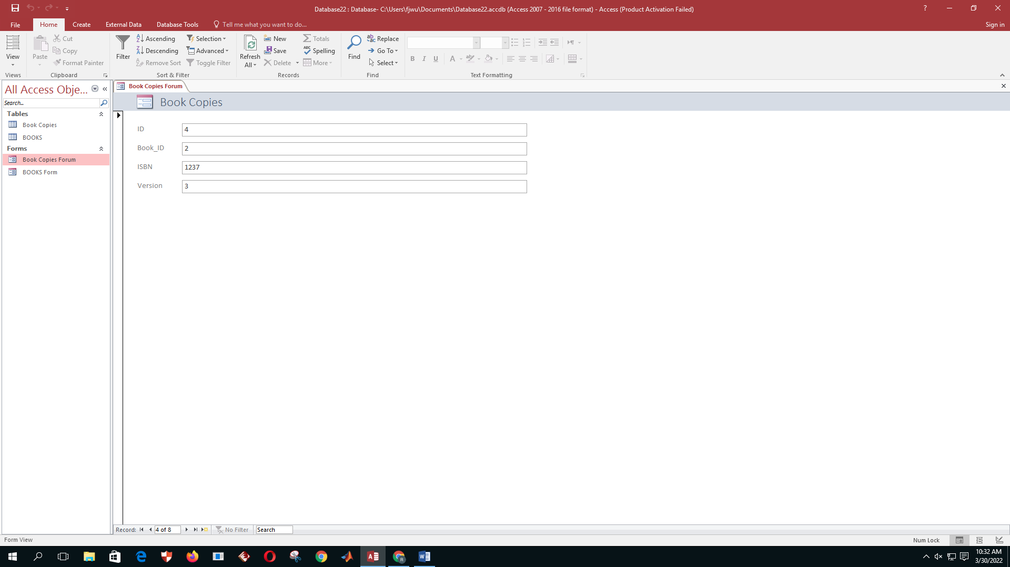

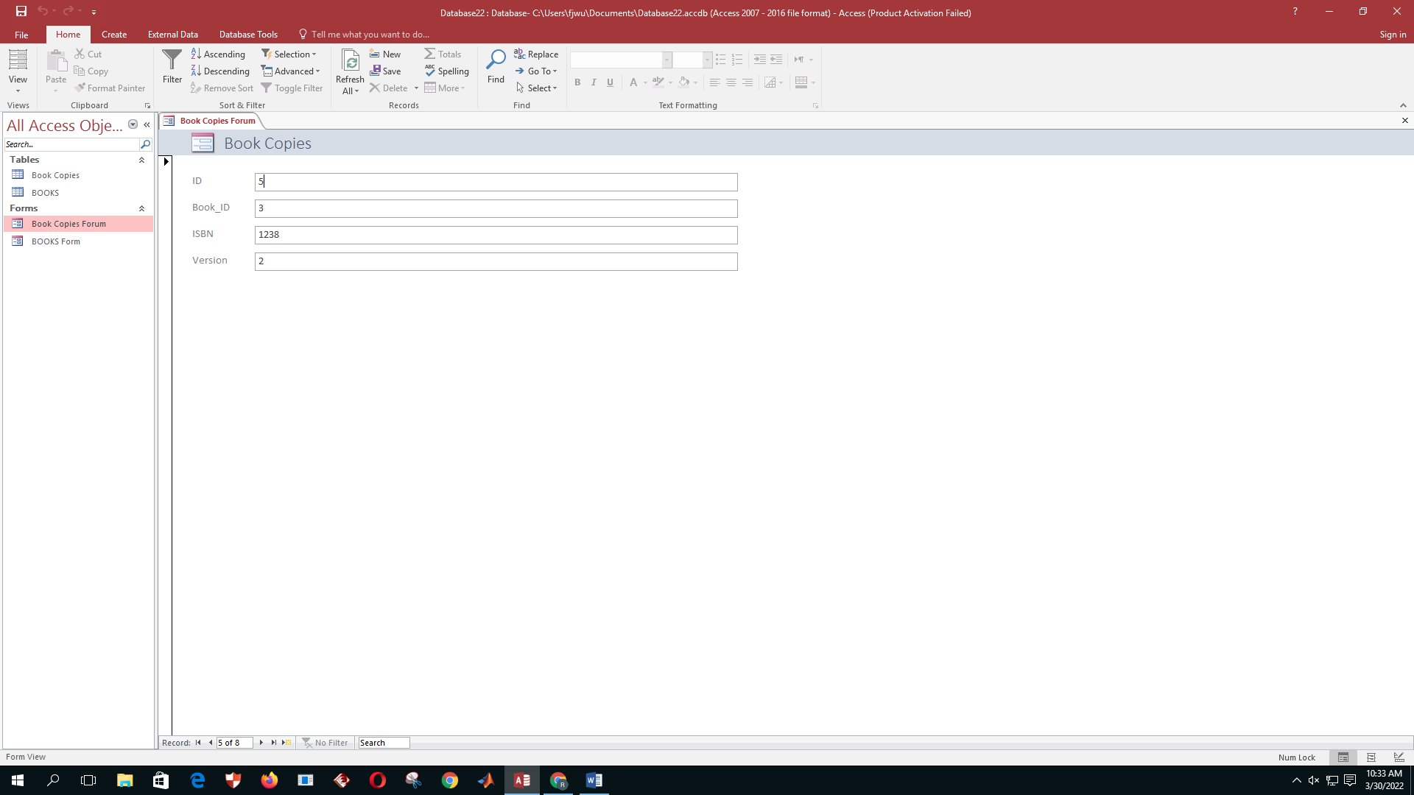

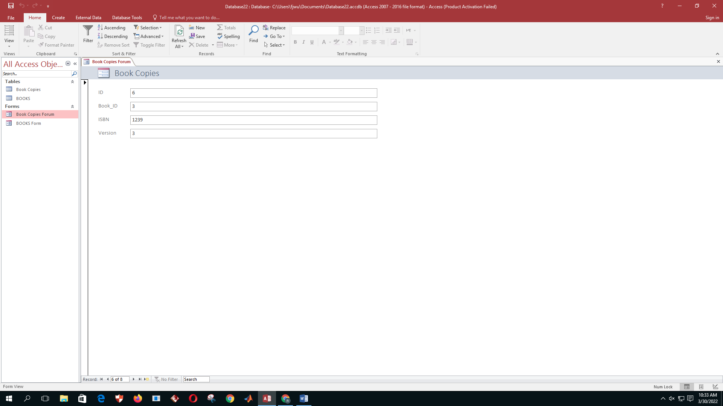

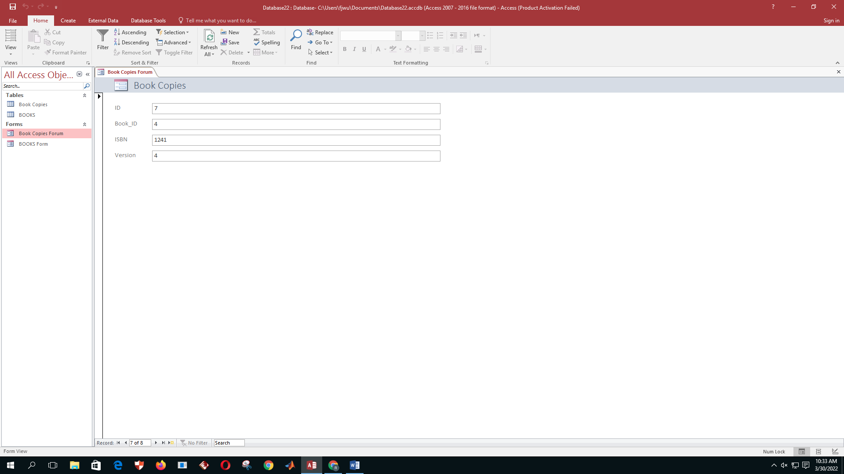

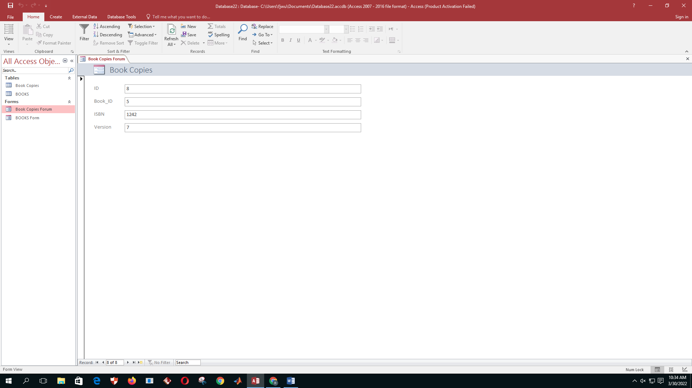

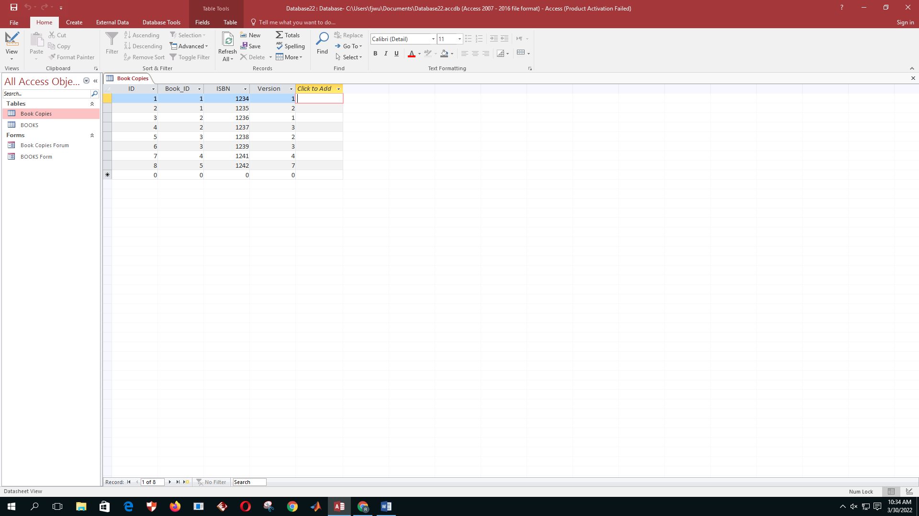

1. Establish the Relationship between “Books” and “Book Copies” tables.

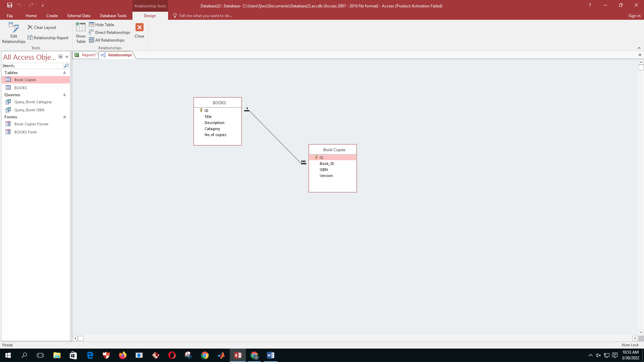

1. Write a query called “Query_Book category” to display all books which belongs to given category; E.g. Category 02.

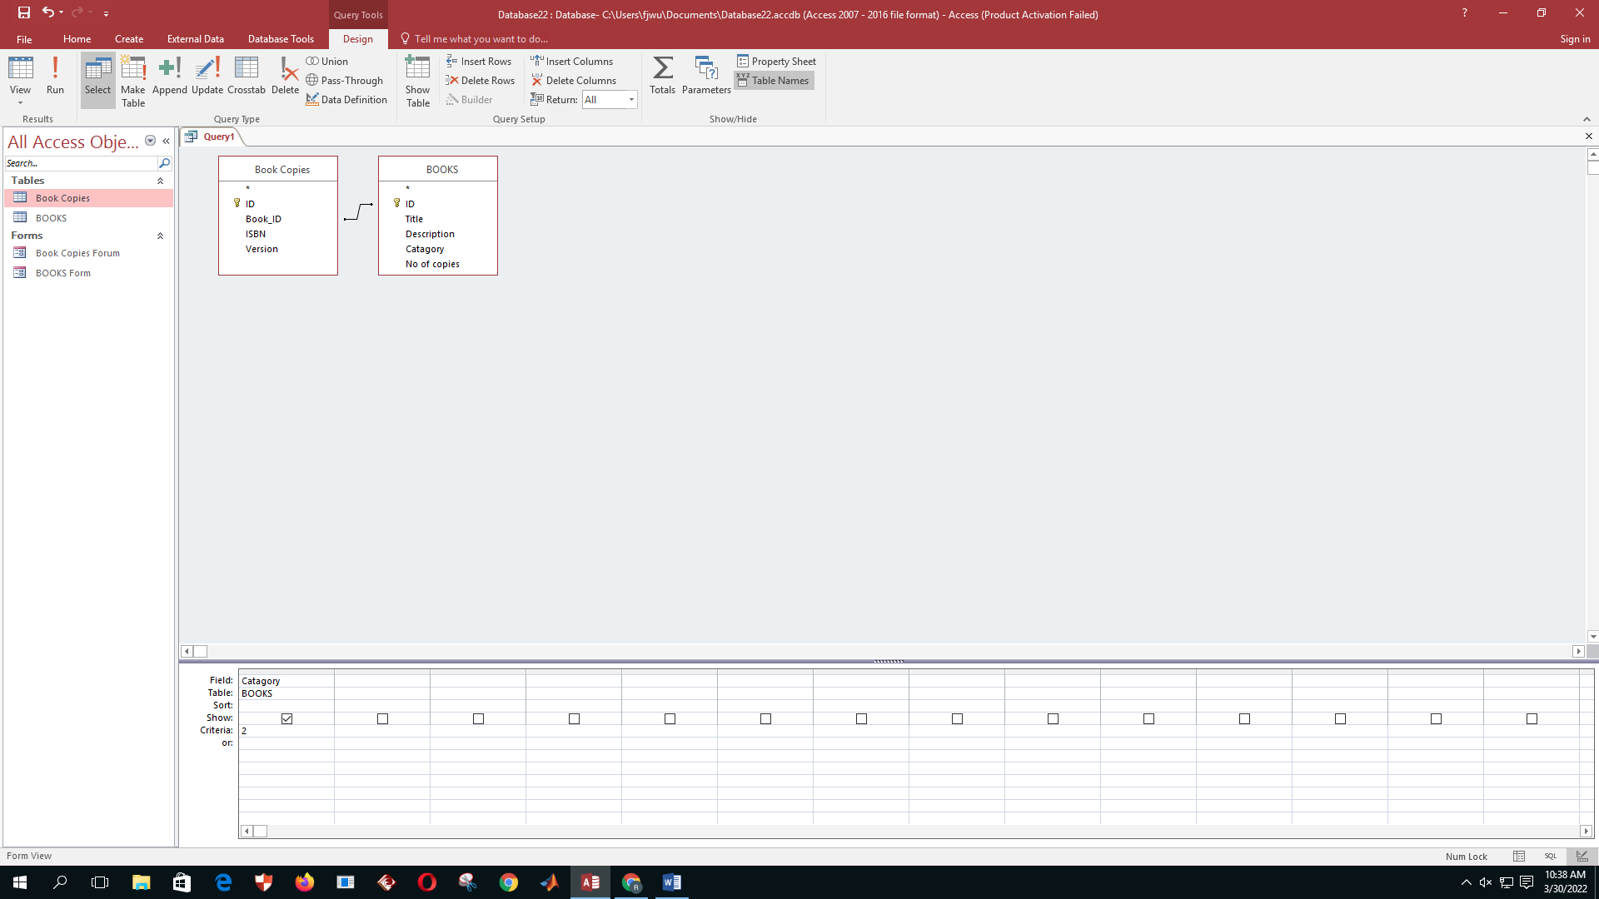

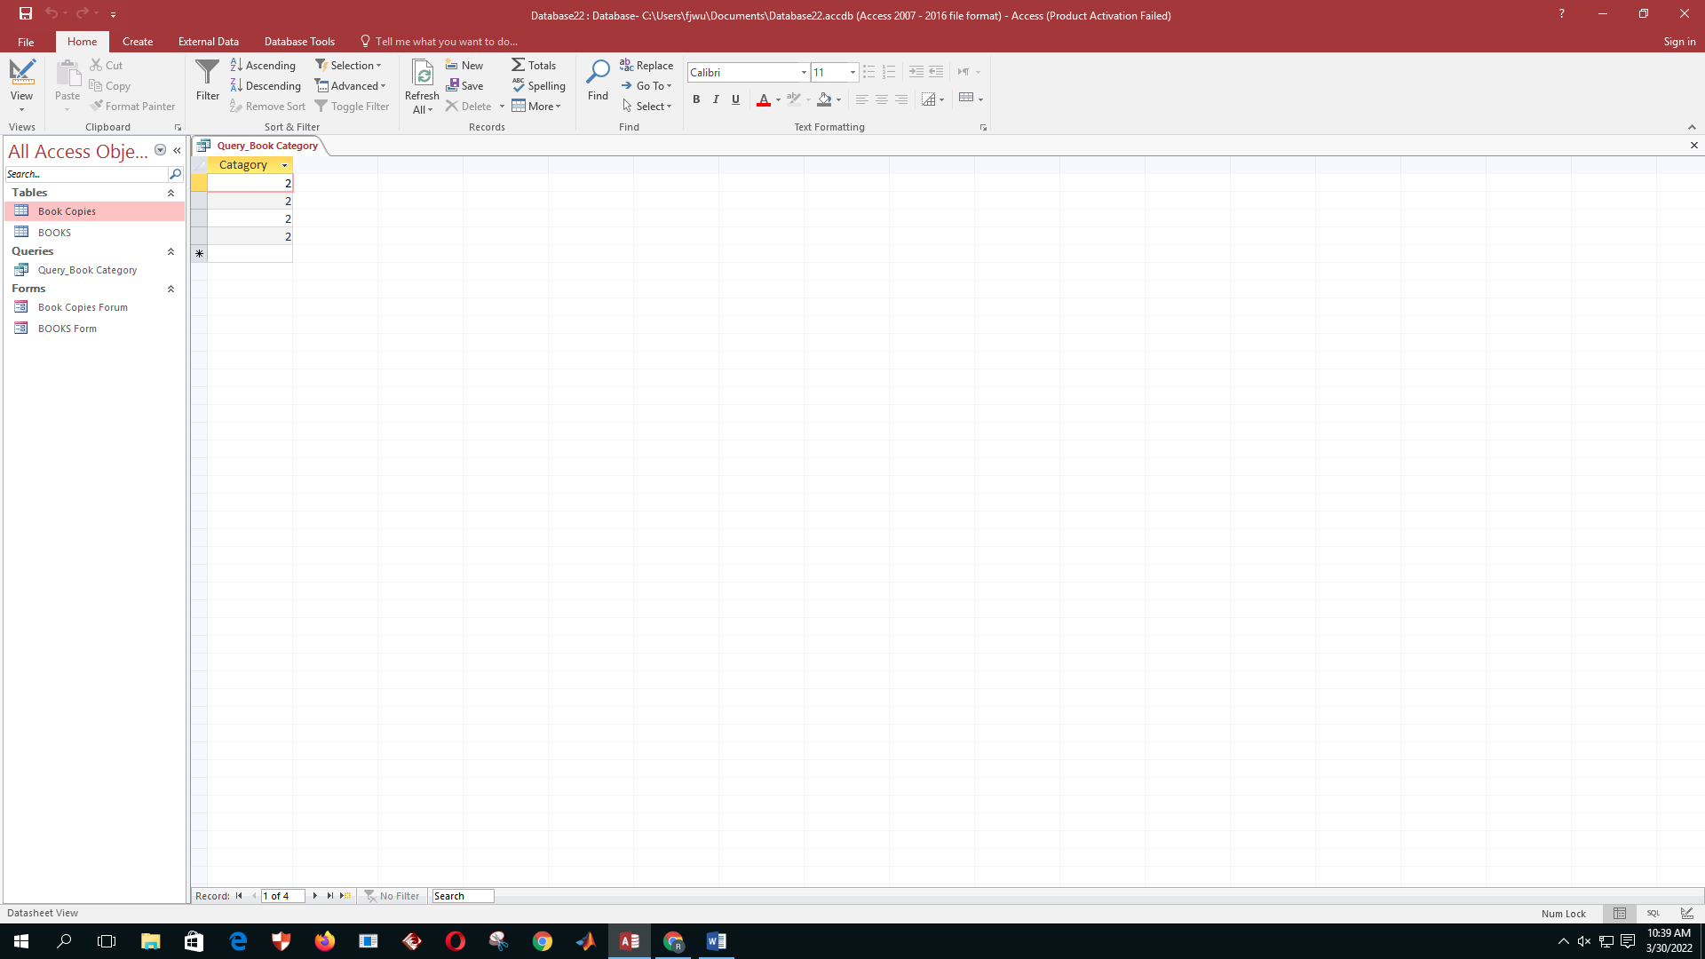

1. Write a query called “Query_Book ISBN” to display book details which belongs to given ISBN. Book Detail include ISBN, Version, Title, Description, Number of Copies.

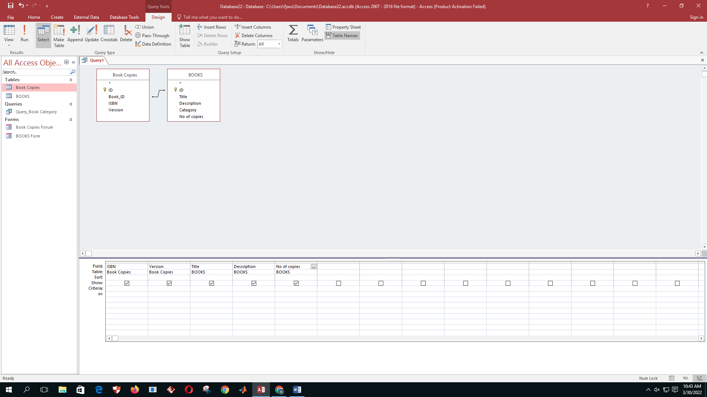

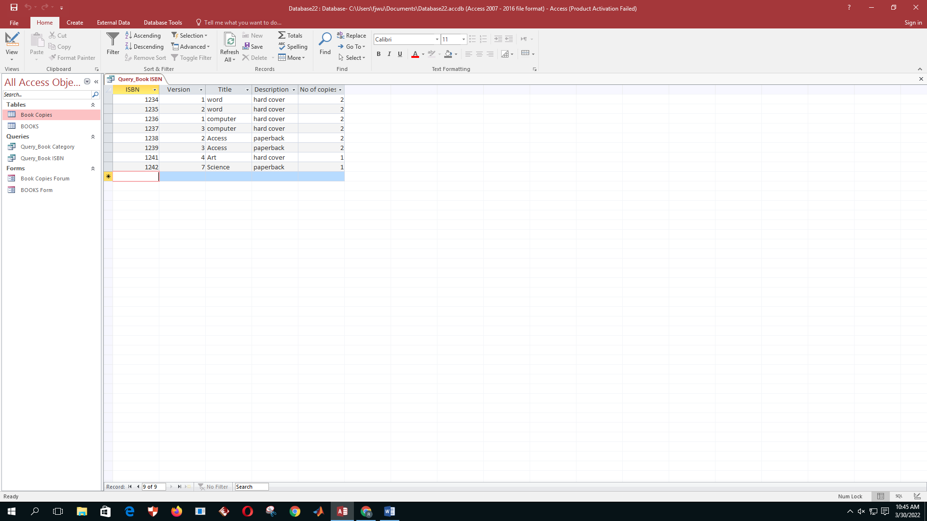

1. Create a report called “Book Details” using the following format and save it.

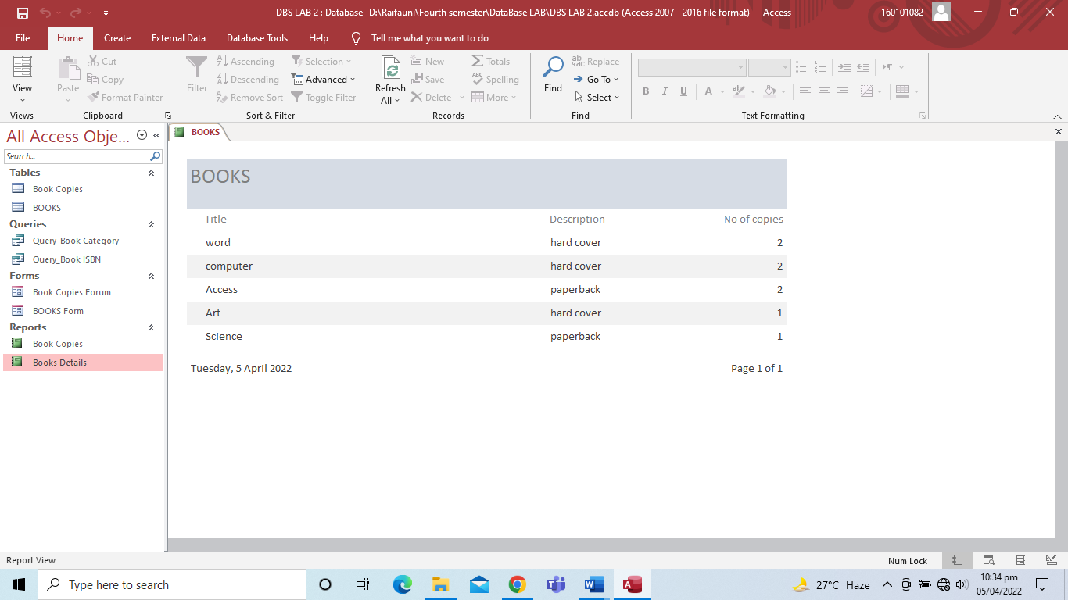

1. Create a report called “Book Details ISBN” of query “Query_Book ISBN” using report wizard.

